# Module 3 Lab 2

# Brandon Trinkle

# IFT 458: Middleware Prog & Database Sec

# Professor: Dinesh Sthapit

# Feb 22, 2025

# Module 3 Lab 2

1. *Screenshot of the config.env file showing the added environment variables.*

1. *Screenshots of the loanModel.js, loanController.js, loanRoutes.js, and server.js files showing the code and file structure. **Multiple screenshots, see deliverables.\*\**

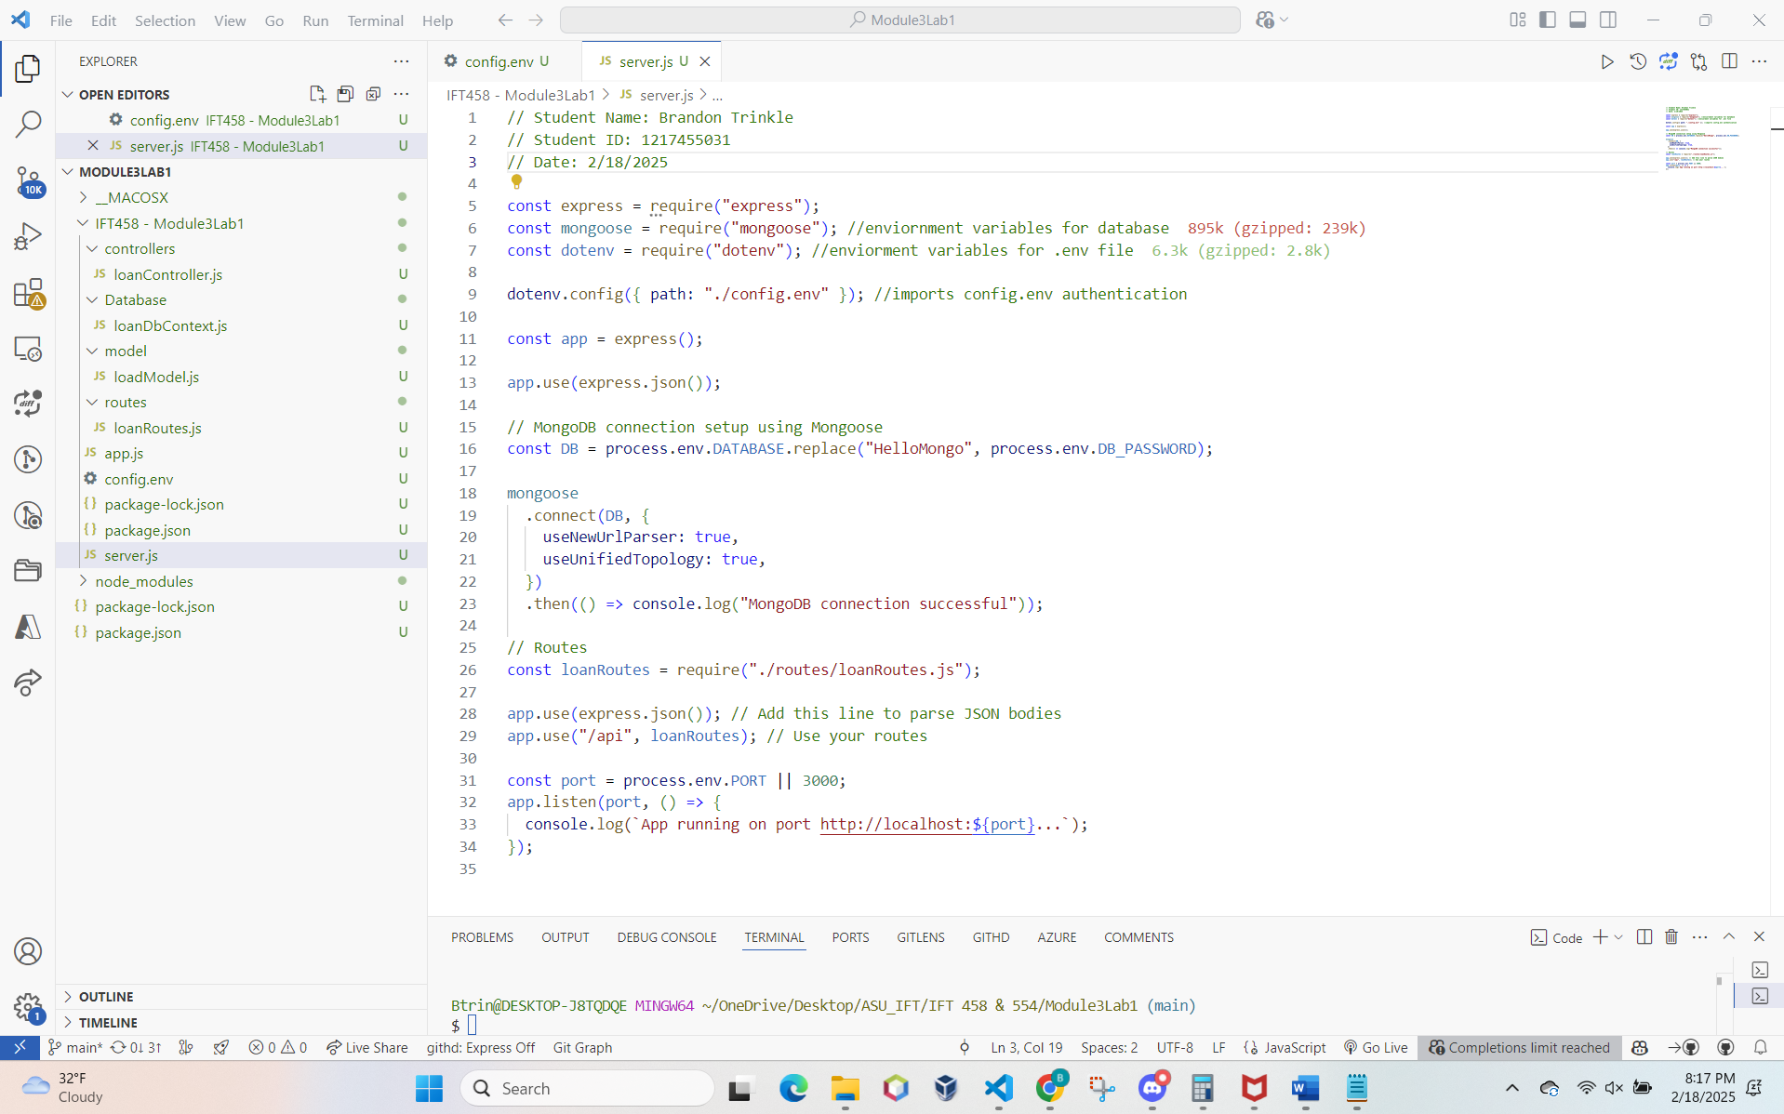

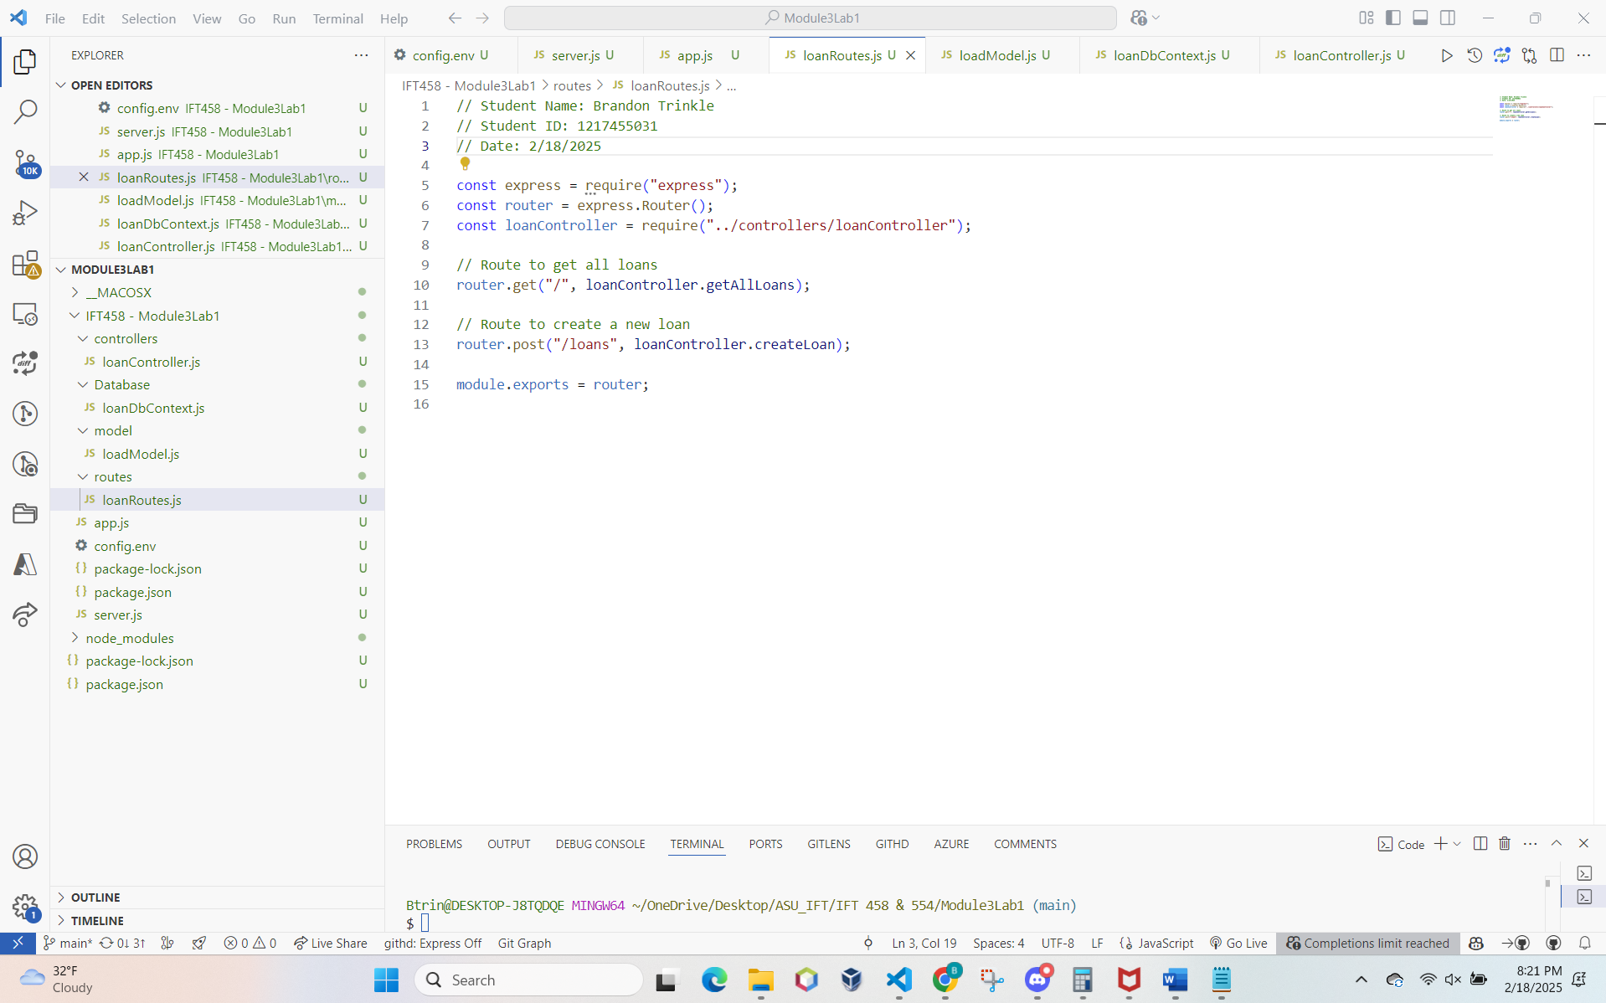

1. *Deliverable: Screenshot of the loanDbContext.js file within the dataBaseManager folder showing the modified code.*

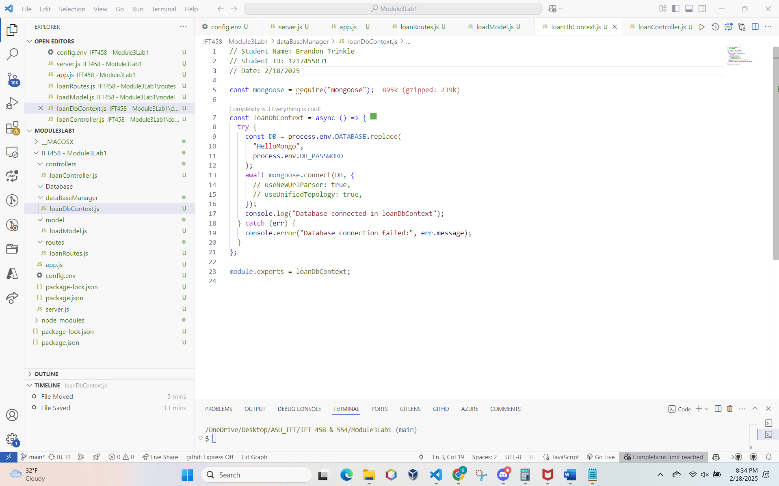

1. *Screenshot of the loanController.js file showing the implemented controller logic.*

1. *Screenshot of the app.js file showing the added routes and their configuration.*

* *6* 
  + *A. Take a screenshot of the Postman request showing the successful addition of data.*
  + *Open MongoDB terminal and verify that the data has been successfully inserted.*
  + *Take a screenshot of the MongoDB terminal showing the added data.*

*Note: connected to MongoDB*

*Note: I had issues with postman, so I used curl to send a post request to the server. I gave myself an absurd interest rate as a result!*

*Note: MongoDB was updated.*